Kubernetes Task -7

Task 1: Execute all yaml files shown in video.
Task 2: Taint a Node and Schedule a Tolerant Pod Taint a node with special=true:NoSchedule. Create a pod with a toleration that matches the taint, allowing it to be scheduled on the tainted node.
Task 3: Use NodeSelector to Schedule a Pod on a Specific Node Label a node with env=dev. Create a pod with a nodeSelector that schedules it only on the node labeled env=dev.
Task 4: Use Node Affinity with Soft Scheduling Label a node with env=test. Create a pod with PreferredDuringSchedulingIgnoredDuringExecution node affinity, preferring to schedule it on a node labeled env=test. Remove the label and verify the pod continues to run.
Task 5: Implement Node Affinity with Hard Scheduling Create a pod with RequiredDuringSchedulingIgnoredDuringExecution node affinity, ensuring it will only be scheduled on a node labeled env=prod. Verify the pod cannot be scheduled if no node has the env=prod label.
Task 6: Taint a Node and Use NoExecute with Toleration Seconds Taint a node with special=true:NoExecute. Create a pod with a tolerationSeconds field (e.g., 60 seconds) and observe it gets evicted after 60 seconds on the tainted node.

Task 1: Execute all yaml files shown in video.
A) How to add toleration to pod using operator “Equal”?

1. Apply a taint to a Node first
For example, taint k8s-worker1:
kubectl taint nodes k8s-worker1 special=true:NoSchedule
Verify:
kubectl describe node k8s-worker1 | grep -i taint
You should see:
Taints: special=true:NoSchedule
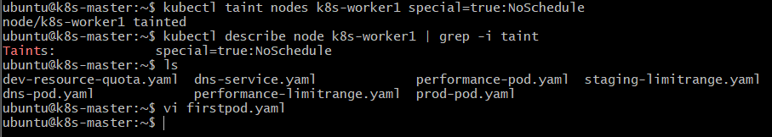

2. Create the Pod YAML
Save as firstpod.yaml:
apiVersion: v1
kind: Pod
metadata:
name: firstpod
spec:
containers:
- name: firstcontainer
image: nginx
imagePullPolicy: Never

tolerations:
- key: "special"
operator: "Equal"
value: "true"
effect: "NoSchedule"

3. Understand the Equal toleration
The important part is:
tolerations:
- key: "special"
operator: "Equal"
value: "true"
effect: "NoSchedule"

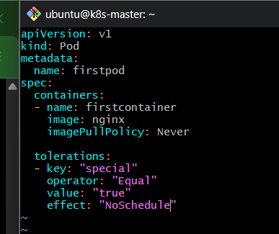
This means:
Node Taint
│
│ special=true:NoSchedule
↓
Scheduler
│
↓
Pod Toleration
│
│ key=special
│ operator=Equal
│ value=true
│ effect=NoSchedule
↓
MATCH ✅
│
↓
Pod is allowed on the node

4. Flow
- We first put a taint on k8s-worker1:
special=true:NoSchedule
- Because of NoSchedule, a normal Pod without a matching toleration cannot be scheduled on that node.
- Our Pod contains a toleration with:
  - key: special
  - operator: Equal
  - value: true
  - effect: NoSchedule
- With operator: Equal, Kubernetes checks that both the key and value match the Node's taint.
- The Node has special=true, and the Pod tolerates special=true, so the toleration matches.
- Therefore, the Pod is allowed to be scheduled on the tainted node.

5. Apply and verify
kubectl apply -f firstpod.yaml
Check:
kubectl get pod firstpod -o wide
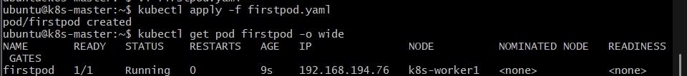
You should see the Pod scheduled on the node that has the matching taint, assuming that node is otherwise suitable.
You can also verify the toleration:
kubectl describe pod firstpod
Look for:
Tolerations:
special:Equal=true

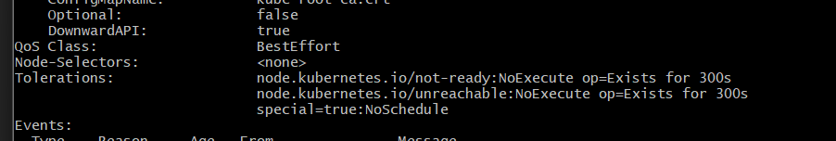

B) How to taint node using PreferNoSchedule?

1. Taint the Node
For example, taint k8s-worker1:
kubectl taint nodes k8s-worker1 special=true:PreferNoSchedule
Verify:
kubectl describe node k8s-worker1 | grep -i taint
You should see:
Taints: special=true:PreferNoSchedule
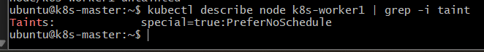

2. Pod with matching toleration
apiVersion: v1
kind: Pod
metadata:
name: firstpod
spec:
containers:
- name: firstcontainer
image: nginx
imagePullPolicy: Never

tolerations:
- key: "special"
operator: "Equal"
value: "true"
effect: "PreferNoSchedule"

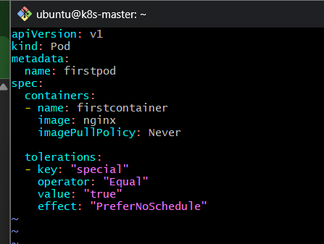
Apply:
kubectl apply -f firstpod.yaml
Check:
kubectl get pod firstpod -o wide
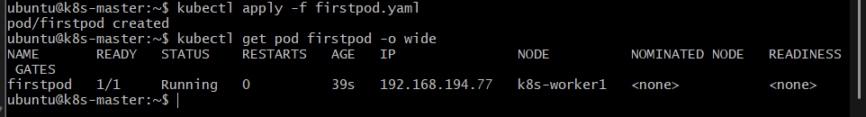

Flow
Node
│
│ special=true:PreferNoSchedule
↓
┌───────────────┐
│ Scheduler │
└───────┬───────┘
│
Does Pod tolerate it?
/ \
Yes No
│ │
↓ ↓
Can schedule Try to avoid
on this node this Node

Flow
- k8s-worker1 receives the taint special=true:PreferNoSchedule.
- The scheduler sees that the Node has a soft restriction.
- If a Pod has the matching toleration, it can run on the Node.
- If a Pod does not have the toleration, Kubernetes tries to avoid that Node.
- However, unlike NoSchedule, the Pod can still be scheduled there if Kubernetes doesn't have a better suitable option.
C) How to add toleration to pod using operator Exists ?

1. Apply the taint to the Node
First, make sure k8s-worker1 has this taint:
kubectl taint nodes k8s-worker1 special=true:NoSchedule
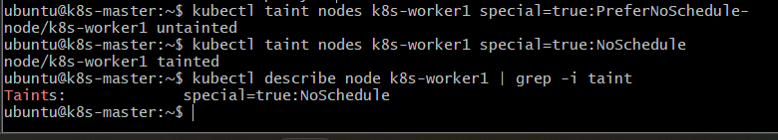

2. Create firstpod.yaml

vi firstpod.yaml
Use:
apiVersion: v1
kind: Pod
metadata:
name: firstpod
spec:
containers:
- name: firstcontainer
image: nginx
imagePullPolicy: Never

tolerations:
- key: "special"
operator: "Exists"
effect: "NoSchedule"
Save and exit.
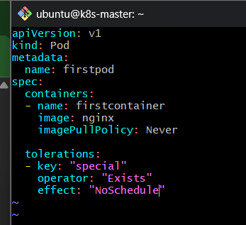

3. Apply the Pod
kubectl apply -f firstpod.yaml
Check:
kubectl get pod firstpod -o wide

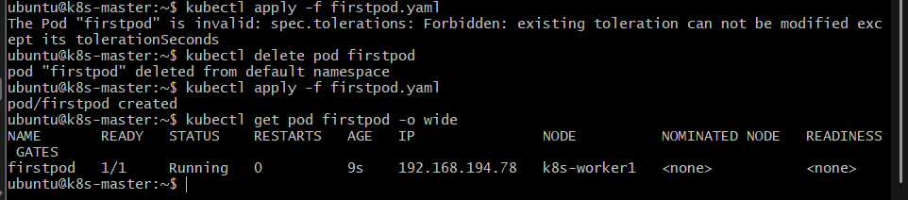

4. How Exists works
The important part is:
tolerations:
- key: "special"
operator: "Exists"
effect: "NoSchedule"
Suppose the Node has:
special=true:NoSchedule
The Pod has:
special + Exists
The value true is not checked.

Flowchart
Node
│
│ Taint:
│ special=true:NoSchedule
↓
Scheduler
│
↓
Check Pod toleration
│
│ key=special
│ operator=Exists
↓
Does key "special" exist?
/ \
Yes No
│ │
↓ ↓
MATCH ✅ No match ❌
│ │
↓ ↓
Pod allowed Pod cannot
on Node use Node

Flow
- The Node has a taint with the key special.
- The Pod has a toleration with the same key, special.
- The Pod uses operator: Exists.
- Exists means Kubernetes only checks whether the taint key exists.
- It does not care what value the taint has.
- Therefore, all of these would match the Pod's toleration
D) Node selector:

1. Check current Node labels
kubectl get nodes --show-labels
You may see:
k8s-worker1
k8s-worker2
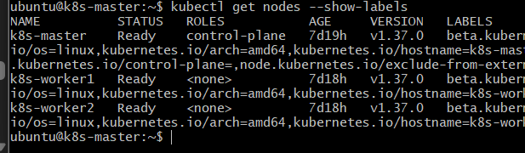

2. Add env=prod label to k8s-worker1
kubectl label node k8s-worker1 env=prod
Verify:
kubectl get nodes --show-labels
Or specifically:
kubectl get node k8s-worker1 --show-labels
You should see:
env=prod
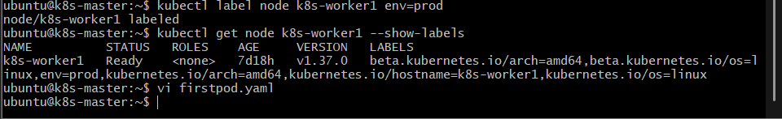

3. Create firstpod.yaml
apiVersion: v1
kind: Pod
metadata:
name: firstpod
spec:
containers:
- name: firstcontainer
image: nginx
imagePullPolicy: Never

nodeSelector:
env: prod
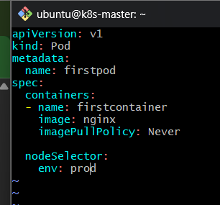

4. Apply the Pod
If firstpod already exists:
kubectl delete pod firstpod
Then:
kubectl apply -f firstpod.yaml
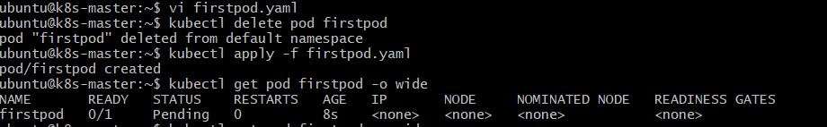

5. Verify where the Pod is running
kubectl get pod firstpod -o wide
You should see:
NAME READY STATUS NODE
firstpod 1/1 Running k8s-worker1

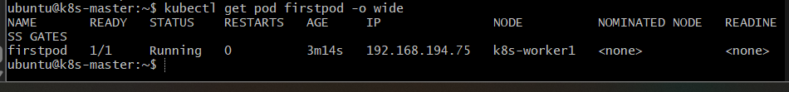

Flowchart
Create Pod
│
↓
nodeSelector: env=prod
│
↓
Scheduler
│
Check Node labels
│
┌──────┴──────┐
↓ ↓
env=prod exists No env=prod
│ │
↓ ↓
Pod scheduled Pod Pending
on that Node

Flow
- You create the Pod with nodeSelector: env=prod.
- The Kubernetes Scheduler looks at the labels of all Nodes.
- It searches for a Node with the exact label env=prod.
- k8s-worker1 has env=prod, so it is a candidate for the Pod.
- The Scheduler places firstpod on that Node.
- If no Node has env=prod, the Pod remains Pending.
E) Node Affinity:

1. First, understand current labels
You currently have:
k8s-worker1 → env=prod
For this example, add env=test to another Node, for example k8s-worker2:
kubectl label node k8s-worker2 env=test
Verify:
kubectl get nodes --show-labels
You should have something like:
k8s-worker1 ... env=prod
k8s-worker2 ... env=test
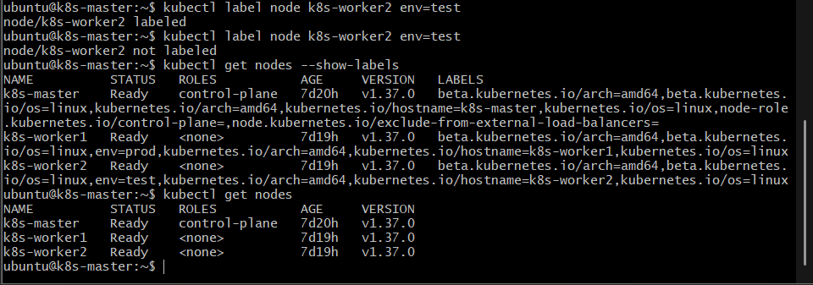

2. Use YAML
apiVersion: v1
kind: Pod
metadata:
name: firstpod
spec:
containers:
- name: firstcontainer
image: nginx
imagePullPolicy: Never

affinity:
nodeAffinity:
preferredDuringSchedulingIgnoredDuringExecution:
- preference:
matchExpressions:
- key: env
operator: In
values:
- test
weight: 1
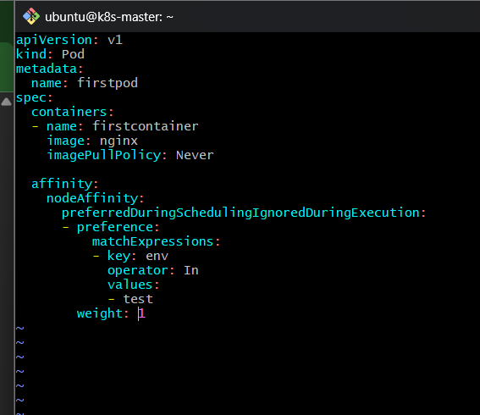
If firstpod already exists:
kubectl delete pod firstpod
Then:
kubectl apply -f firstpod.yaml
Check:
kubectl get pod firstpod -o wide
The scheduler will prefer k8s-worker2 because it has:
env=test
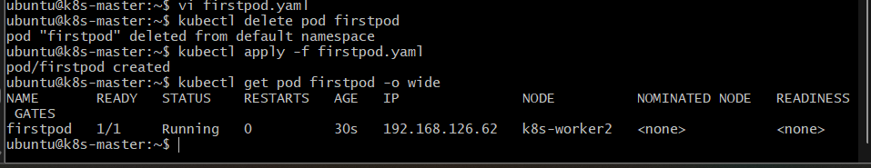

Task 2: Taint a Node and Schedule a Tolerant Pod

Objective
Taint a Node with special=true:NoSchedule and create a Pod with a matching toleration so that the Pod is allowed to run on the tainted Node.

Implementation Steps
2.1 Taint the Node
kubectl taint nodes k8s-worker1 special=true:NoSchedule
Verify:
kubectl describe node k8s-worker1 | grep -i taint
Expected:
Taints: special=true:NoSchedule
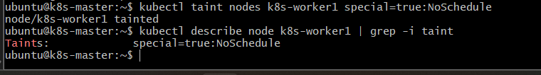
2.2 Create firstpod.yaml
apiVersion: v1
kind: Pod
metadata:
name: firstpod
spec:
containers:
- name: firstcontainer
image: nginx
imagePullPolicy: Never

tolerations:
- key: "special"
operator: "Equal"
value: "true"
effect: "NoSchedule"
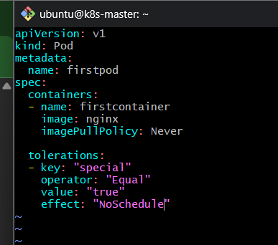
2.3 Create the Pod
kubectl apply -f firstpod.yaml
2.4 Verify
kubectl get pod firstpod -o wide

Outcome
The Pod is successfully scheduled on a Node with:
special=true:NoSchedule
because the Pod has a matching toleration.
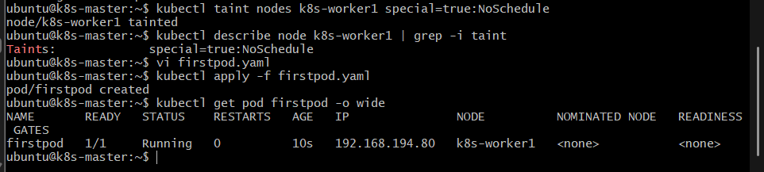

Task 3: Use NodeSelector to Schedule a Pod on a Specific Node

Objective
Label a Node with env=dev and use nodeSelector to ensure the Pod is scheduled only on a Node having that label.

Implementation Steps
3.1 Label the Node
kubectl label node k8s-worker1 env=dev
Verify:
kubectl get node k8s-worker1 --show-labels

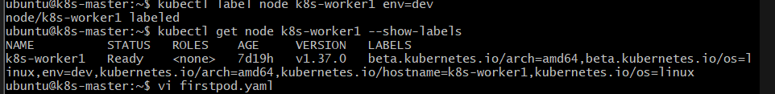
3.2 Create firstpod.yaml
apiVersion: v1
kind: Pod
metadata:
name: firstpod
spec:
containers:
- name: firstcontainer
image: nginx
imagePullPolicy: Never

nodeSelector:
env: dev

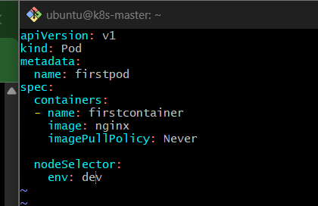
3.3 Create the Pod
kubectl apply -f firstpod.yaml

3.4 Verify
kubectl get pod firstpod -o wide

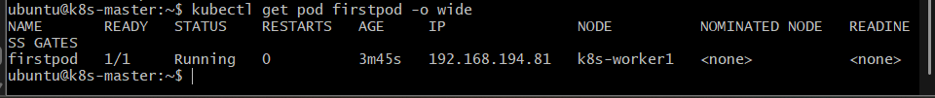

Outcome
The Pod is scheduled only on a Node with:
env=dev
If no Node has env=dev, the Pod remains Pending.

Task 4: Node Affinity with Soft Scheduling

Objective
Use PreferredDuringSchedulingIgnoredDuringExecution to prefer a Node labeled env=test, then remove the label and verify that the already-running Pod continues to run.

Implementation Steps
4.1 Label the Node
kubectl label node k8s-worker1 env=test
Verify:
kubectl get nodes --show-labels

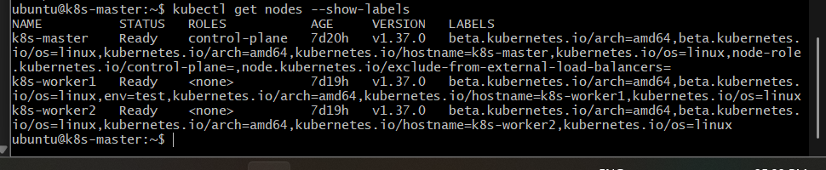
4.2 Create firstpod.yaml
apiVersion: v1
kind: Pod
metadata:
name: firstpod
spec:
containers:
- name: firstcontainer
image: nginx
imagePullPolicy: Never

affinity:
nodeAffinity:
preferredDuringSchedulingIgnoredDuringExecution:
- weight: 1
preference:
matchExpressions:
- key: env
operator: In
values:
- test

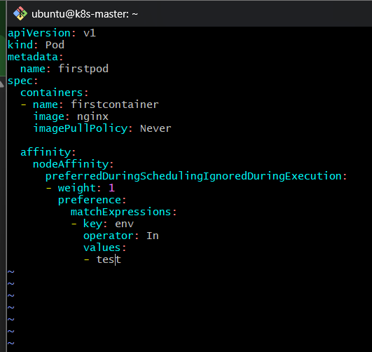
4.3 Create the Pod
kubectl apply -f firstpod.yaml
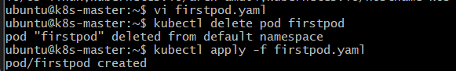
4.4 Verify the Pod
kubectl get pod firstpod -o wide
It should preferably be scheduled on the Node labeled:
env=test

4.5 Remove the label
kubectl label node k8s-worker1 env-
4.6 Verify the Pod
kubectl get pod firstpod -o wide
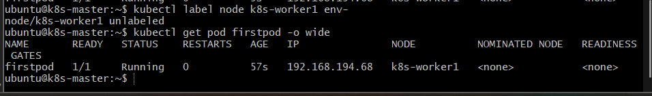

Outcome
The Pod continues running even after env=test is removed.
This demonstrates:
PreferredDuringSchedulingIgnoredDuringExecution
↓
Preference during scheduling
↓
Label removed after scheduling
↓
Existing Pod continues

Task 5: Node Affinity with Hard Scheduling

Objective
Use RequiredDuringSchedulingIgnoredDuringExecution to ensure that the Pod can only run on a Node labeled env=prod.

Implementation Steps
5.1 Create the Pod YAML
First, make sure there is no env=prod label on any Node.
kubectl get nodes -l env=prod

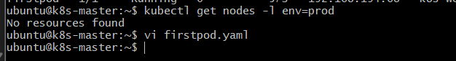
If no Node has the label, create firstpod.yaml:
apiVersion: v1
kind: Pod
metadata:
name: firstpod
spec:
containers:
- name: firstcontainer
image: nginx
imagePullPolicy: Never

affinity:
nodeAffinity:
requiredDuringSchedulingIgnoredDuringExecution:
- nodeSelectorTerms:
- matchExpressions:
- key: env
operator: In
values:
- prod
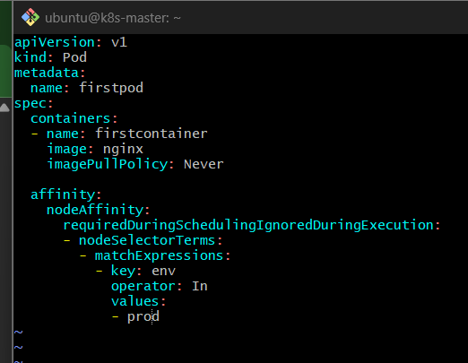
5.2 Create the Pod
kubectl apply -f firstpod.yaml
5.3 Verify
kubectl get pod firstpod -o wide
The Pod should remain:
Pending
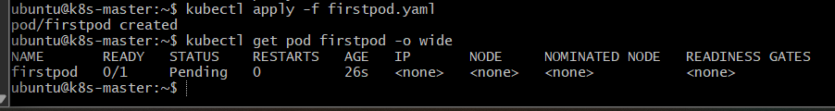
5.4 Check the scheduling reason
kubectl describe pod firstpod
Look at Events. You should see that no suitable Node satisfies the required affinity.
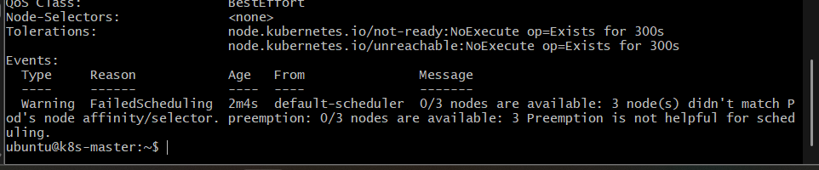
5.5 Add the required label
kubectl label node k8s-worker1 env=prod
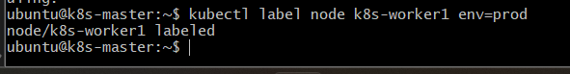
5.6 Delete and recreate the Pod
kubectl delete pod firstpod
kubectl apply -f firstpod.yaml
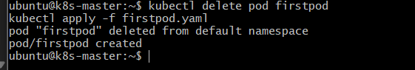
Verify:
kubectl get pod firstpod -o wide

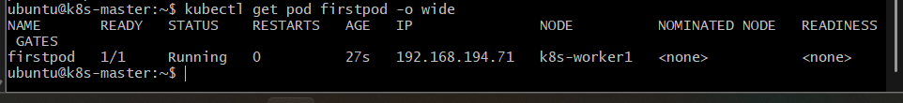

Outcome
Without env=prod, the Pod cannot be scheduled and remains Pending.
After a Node receives:
env=prod
the Pod can be scheduled there.
Hard scheduling = requirement must be satisfied.

Task 6: NoExecute with Toleration Seconds

Objective
Taint a Node with special=true:NoExecute, create a Pod with tolerationSeconds: 60, and observe that the Pod is evicted after the toleration period when the taint is applied.

Implementation Steps
6.1 Taint the Node
kubectl taint node k8s-worker1 special=true:NoExecute
Verify:
kubectl describe node k8s-worker1 | grep -i taint
Expected:
Taints: special=true:NoExecute
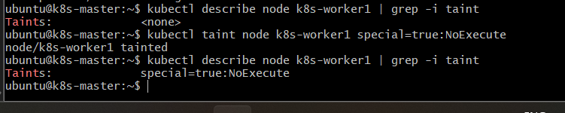
6.2 Create firstpod.yaml
apiVersion: v1
kind: Pod
metadata:
name: firstpod
spec:
containers:
- name: firstcontainer
image: nginx
imagePullPolicy: Never

tolerations:
- key: "special"
operator: "Equal"
value: "true"
effect: "NoExecute"
tolerationSeconds: 60
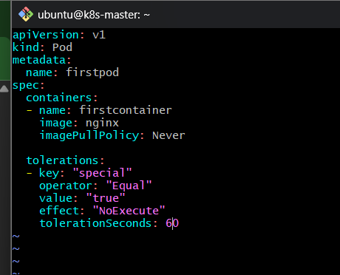
6.3 Create the Pod
kubectl apply -f firstpod.yaml
6.4 Verify
kubectl get pod firstpod -o wide

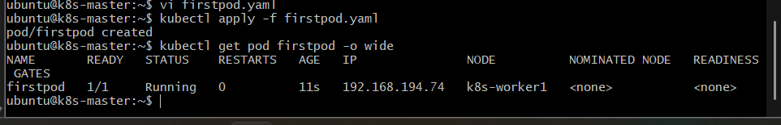

Important for this task
For the eviction test, the Pod needs to already be running on the Node and then encounter the NoExecute taint.
A clean way to demonstrate it is:
- Start the Pod on k8s-worker1 without the NoExecute taint.
- Confirm it is running there.
- Apply:
kubectl taint node k8s-worker1 special=true:NoExecute
- The Pod tolerates the taint for 60 seconds.
- After 60 seconds, if the taint remains, Kubernetes evicts the Pod.
Watch it:
kubectl get pod firstpod -o wide -w
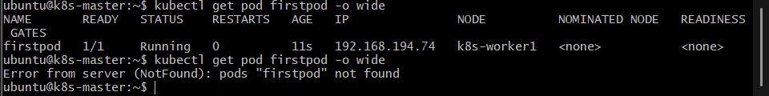

Outcome
The Pod initially continues running because it has:
tolerationSeconds: 60
After approximately 60 seconds, if special=true:NoExecute remains on the Node, the Pod is evicted.

